**CSE5006 Quiz 2 + Sample-Exam (Short and Long)**

**Which of the statements below is incorrect about Docker?**

**Question 1**

a.

After you create a container image, it can go anywhere that Docker is supported.

**b.**

**Docker container is created from running the dockerfile.**

c.

Docker is a portable runtime application environment.

d.

You can package an application and its dependencies into a single, immutable artifact that is called an image.

e.

You can run different application versions with different dependencies simultaneously.

**Question 2**

**The following statements are correct about the Amazon S3, except:**

a.

Docker containers running on Amazon Elastic Compute Cloud (Amazon EC2).

**b.**

**MySQL cannot be migrated to Amazon Aurora Serverless database.**

c.

S3 bucket is secured with a bucket policy.

d.

Docker image can be pulled from Amazon Elastic Container Registry (Amazon ECR).

e.

DynamoDB is a relational database located in the Amazon S3.

**In which part of the HTML tag should functions be written?**

**Question 3**

a.

Title

b.

H2 tag

**c.**

**Head**

d.

H1 tag

e.

Body

**Question 4.**

**DevOps (that is, the combination of Development and Operations) is a combination of cultural philosophies, practices, and tools. DevOps is about removing the barrier between development and operations teams and getting them to communicate with each other. What are the correct practices in DevOps:**

**a.**

**Infrastructure as code and automate everything.**

b.

Automate everything and Code Sharing.

c.

Code sharing and notification system.

d.

Automatic compiling and Code Monitoring.

e.

Microservice architecture, Continuous integration and continuous delivery (CI/CD), Management integration architecture.

**The following statements are incorrect about the definition of the code repository, except:**

**Question 5:**

a.

Source code is invaluable knowledge. Therefore, it must be stored in the code repository.

b.

If we store our source code in a repository in a private mode, it means it cannot be shared with anyone.

c.

If a member joins the team in the repository, they must provide all details such as email, username, and date of birth.

d.

Code repositories only can be used by open-source software developers.

**e.**

**A central repository is important in software development because it enables developers to collaborate and share their work.**

**Which one of the following statements is correct about a Virtual Machine or a Container:**

**Question 6**

**a.**

**Container uses a form of operating system (OS) virtualisation.**

b.

Container virtualizes physical hardware.

c.

Container allows developers to improve the CPU and memory utilization of physical machines.

d.

Containers enable microservice architectures.

e.

Container does not need to include a guest OS in every instance.

**These are the important features of Node.js, except:**

**Question 7**

a.

No Buffering.

**b.**

**client-side scripting**

c.

Event driven

d.

Single threaded.

e.

Asynchronous.

**NGINX can be used for a variety of purposes, except:**

**Question 8**

a.

Load Balancing

b.

Security

**c.**

**File Sharing**

d.

Reverse Proxying

e.

Web serving

**Which of the statements below is correct about Docker?**

**Question 9**

**a.**

**You can package an application and its dependencies into a single, immutable artifact that is called an image.**

b.

Docker is a programming language.

c.

Docker is the same as a virtual machine.

d.

Developers can create, distribute, and run containers consistently only at the same environments.

e.

Docker only work in a Linux environment.

**‘How does virtualization work?**

**Question 10**

a.

Migrating applications from the old system into a newer one (e.g., an old computer into an upgraded one).

b.

Optimizing resources in the current system (e.g., disk fragmentation).

**c.**

**Create one or more independent machines where each machine can behave like an independent computer that can handle independent tasks.**

d.

Putting all servers (e.g., mail server, web server) into separate physical servers.

e.

Splitting tasks to a distributed resource (e.g., hard disk, RAM in other CPUs).

**Question 11.**

**Frontend and backend are two terms used to describe the two main parts of a website or web application. The frontend is the part that users see and interact with, while the backend is the part that users don't see but is essential for the website to function.**

**The front end is responsible for a website or web application's**user interface (UI)**. This includes the HTML, CSS, and JavaScript that comprise the website's design, layout, and functionality. Frontend developers use these languages to create interactive and visually appealing websites that users can easily use.**

**The backend is responsible for the**data and logic**of a website or web application. This includes the**server‑side code**that stores and processes data and the business logic determining how the website or web application works. Backend developers use languages like Java, Python, or PHP to create the backend of a website or web application.**

**Question 12.**

**API stands for**application programming interface**, a set of definitions and protocols for building and integrating**application software**.**

**APIs let your product or service** communicate**with other products and services without having to know how they’re implemented. This can**simplify **app development, saving time and money. When designing new tools and products—or managing existing ones—APIs give you flexibility; simplify design, administration, and use; and provide opportunities for innovation.**

**APIs are sometimes considered contracts, with documentation representing an**agreement **between parties: If party 1 sends a remote request structured a particular way, this is how party 2’s software will respond.**

**Question 13.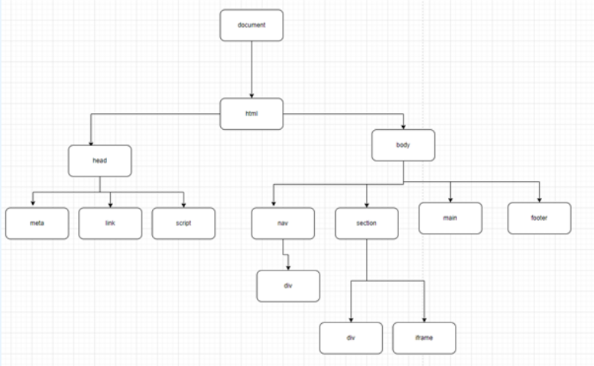**

**Examine the above picture, and put the right text in the blank spot of the following text below:**

**The above picture shows a DOM tree for a**HTML**document. A**DOM tree**starts from the topmost element, an**HTML element**, and branches out as per the occurrence and nesting of HTML elements in the document. Whenever an HTML element is found, it creates a DOM node (Node) object from its respective class (constructor function).**

**Question 14.**

**Find the term for the following definitions:**

|  |  |
| --- | --- |
| **Read-only template that is used to create writeable containers** | **Container image** |
| **The runnable instance of an image.** | **Container** |
| **Plain text file that provides instructions to create a container image** | **Dockerfile** |

**Question 15.**

**Find the term for the following definitions:**

|  |  |
| --- | --- |
| **A highly scalable, highly performing container orchestration service that supports Docker containers.** | **Amazon Elastic Container Service**  **(Amazon ECS)** |
| **You can use the open-source container management platform to deploy and manage containerized applications at scale.It manages clusters of EC2 instances and runs containers on those instanceswith deployment, maintenance, and scaling processes.** | **Amazon Elastic Kubernetes**  **Service (Amazon EKS),** |
| **A fully managed, cloud-based Docker image registry that makes it easy for you to store, manage, and deploy Docker container images.** | **AmazonElastic Container Registry (Amazon ECR)** |

**Question 16.**

**A proxy server is a server that acts as an intermediary between a client and a server. When a client requests a resource from a server, the proxy server forwards the request to the server and then returns the response to the client.**

**Proxy servers can be used for a variety of purposes.**

**In this questions, find the match between definitions and terms:**

|  |  |
| --- | --- |
| **Proxy servers can be used to filter traffic and block malicious content. This can help to protect the client's computer from malware and other threats.** | **Security** |
| **Proxy servers can be used to hide the client's real IP address from the server. This can be useful for protecting privacy or for bypassing geo-blocking.** | **Privacy** |
| **Proxy servers can be used to distribute traffic across multiple servers. This can help to improve performance and reliability.** | **Load balancing** |
| **Proxy servers can be used to cache frequently accessed resources. This can improve performance by reducing the amount of traffic that needs to be sent to the original server.** | **Performance** |

**Which HTTP method would you use to update an existing contact's name in the database?**

**Question 17**

**a.**

**PUT**

b.

PATCH

c.

POST

d.

DELETE

e.

GET

**What command would you use to remove a specific contact (with id=11), in your case of your assignment, from the database?**

**Question 18**

a.

http delete http://localhost/api/contacts/11/phone/1

b.

http delete http://localhost/api/phone/1/contacts/11/

**c.**

**http delete http://localhost/api/contacts/11/**

d.

http post http://localhost/api/contacts/11/

e.

http post <http://localhost/api/contacts/11/phone/1>

**Question 19.**

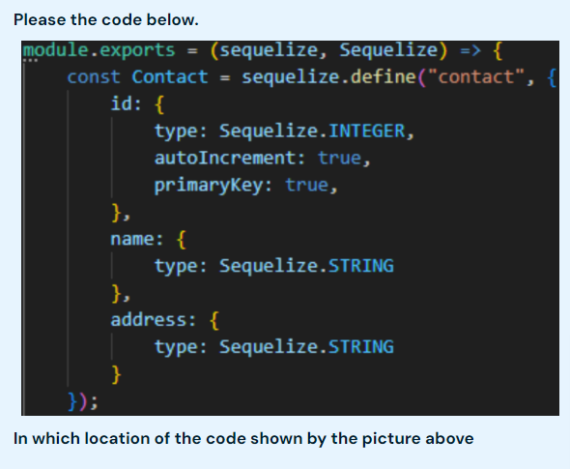

a.

contact.controller.js

b.

Contact.js

c.

ContactList.js

**d.**

**contact.model.js**

e.

index.js

**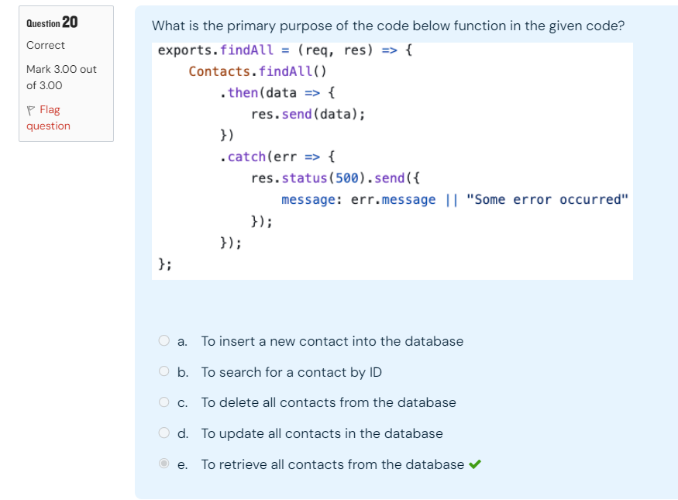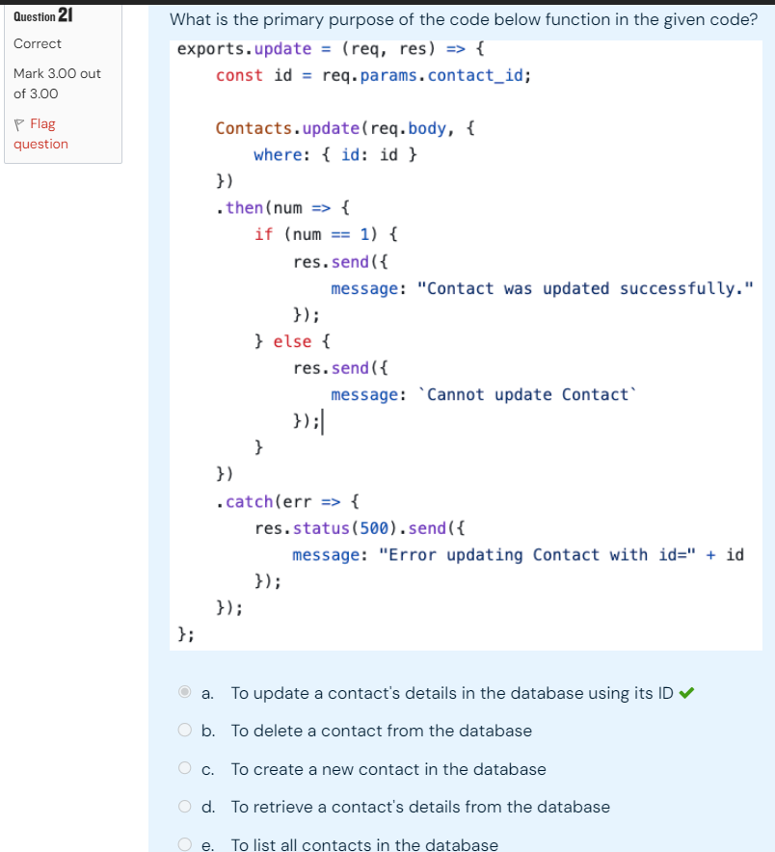**

**In task 1, we have not changed any backend modification task. What must be included in the HTTP request to create a new contact?**

**Question 22**

a.

Only the phone number

b.

Only the address

c.

The ID, name, and number

**d.**

**Only the name**

e.

The ID and phone type

**What is the primary purpose of using APIs in your assignment?**

**Question 23**

a.

To be able to serve multiple sources (e.g. input from mobile)

b.

To manage user authentication

**c.**

**To execute CRUD operations on the database**

d.

To adjust with the backend whatever type of the database

e.

 To create user interface better

**In task 1 part 2, how do we**

**Question 24**

**"Change the button label in phone component from "Add" to e.g "Add Choiru’s Phone"?**

**How was the button label changed dynamically following the contact's input?**

**a.**

**Insert the contact object that has name property {contact.name} into the button's label.**

b.

By adding the word "Choiru" between the <button> tags

c.

Add a javascript component called {contact.name} into the text area

d.

Add connection to contact.js file that has property of contact

e.

Add a react component called {contact} into the button's label.

**What was the primary goal of Task 1 in the assignment?**

**Question 25**

**a.**

**Modifying existing User Interface elements**

b.

Debugging the application using JavaScript

c.

 Adding new components to the application

d.

Writing Documentation

e.

Implementing new features using React Js

**Explain the concept of Version Control Systems (VCS) and their importance in software development.**

Version Control Systems (VCS) are tools that help developers manage changes to their code. They track every change, allowing teams to collaborate, undo mistakes, and experiment with new features without breaking the main code. Popular VCS tools include Git and SVN.

**Explain the concept of state in React. How does it differ from props? Provide an examples**

State in React

State is like a component's own memory. It stores data that can change over time. When the state changes, the component re-renders itself to show the new data.

Difference between State and Props:

* Props: Data passed down from a parent component. They cannot be changed by the child component.
* State: Data managed within the component itself. It can be changed.

Example:

Imagine a counter. The current count is the state. When you click a button to increase the count, the state changes, and the counter updates.

**What are the advantages of using an Object-Relational Mapping (ORM) tool like Sequelize in web development? (In simple and short sentences)**

Here are the advantages of using an ORM like Sequelize:

* Simplified Database Interactions: You can work with database tables as objects, making it easier to understand and manage.
* Reduced SQL Complexity: You don't need to write complex SQL queries. Sequelize generates them for you.
* Improved Developer Productivity: It saves time by automating tasks and reducing errors.
* Database Abstraction: You can easily switch between different databases without major code changes.
* Additional Features: It offers features like query building, relationships, and migrations for better database management.

**Discuss how Sequelize simplifies database operations compared to writing raw SQL queries.**

Sequelize simplifies database operations by:

* Abstraction: It hides the complexity of SQL, making it easier to work with databases.
* Object-Relational Mapping (ORM): You can interact with database tables as objects, making code more intuitive.
* Automatic Query Generation: It generates SQL queries for you based on your code.
* Simplified Query Building: You can build complex queries using simple methods.
* Data Validation and Type Casting: It ensures data integrity and handles type conversions automatically.
* Reduced Boilerplate Code: You write less code to achieve the same results.

Overall, Sequelize makes database interactions more efficient and less error-prone.

**Explain the different categories of AWS services**

1. Compute:

* EC2: Virtual computers you can rent.
* Lambda: Run code without managing servers.

2. Storage:

* S3: Store and retrieve any amount of data.
* EBS: Disk drives for virtual machines.
* FSx: File systems for storing files.

3. Database:

* RDS: Managed databases like MySQL, PostgreSQL.
* DynamoDB: NoSQL database for fast and scalable apps.
* Redshift: Data warehouse for analyzing big data.

4. Networking:

* VPC: Your own private network in the cloud.
* Route 53: DNS service for routing internet traffic.
* CloudFront: Content Delivery Network (CDN) for faster content delivery.

5. Analytics:

* Kinesis: Process real-time data streams.
* EMR: Process big data using tools like Hadoop and Spark.
* Athena: Query data stored in S3 without setting up a data warehouse.

6. Machine Learning:

* SageMaker: Build, train, and deploy machine learning models.
* Rekognition: Analyze images and videos.
* Comprehend: Understand and extract information from text.

7. Security:

* IAM: Manage user access and permissions.
* WAF: Protect web applications from attacks.
* KMS: Manage and control cryptographic keys.

**What are the primary advantages of using AWS cloud services over traditional on-premises infrastructure?**

Here are the key advantages of using AWS cloud services:

**1. Cost-Effective:**

* **Pay-as-you-go:** Pay only for the resources you use, reducing upfront costs.

**2. Scalability:**

* **Rapid Scaling:** Easily adjust resources to meet changing demands.

**3. Reliability:**

* **High Availability:** Ensure your applications are always available.

**4. Security:**

* **Robust Security:** Benefit from AWS's advanced security measures.

**5. Flexibility:**

* **Wide Range of Services:** Access a variety of services to build and innovate.

**6. Less Management:**

* **Managed Services:** Let AWS handle infrastructure tasks, freeing up your team.

**](https://aws.amazon.com/products/compute/" \l ":~:text=With%20AWS%20compute%20you%20pay,term%20contracts%20or%20complex%20licensing." \t "_blank)**[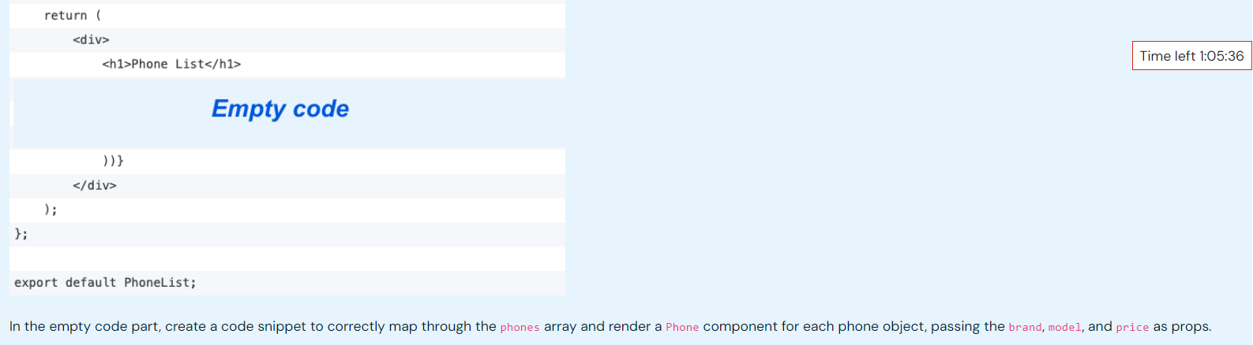](https://aws.amazon.com/products/compute/" \l ":~:text=With%20AWS%20compute%20you%20pay,term%20contracts%20or%20complex%20licensing." \t "_blank)

{phones.map((phone) => ( <Phone key={phone.model} brand={phone.brand} model={phone.model} price={phone.price} /> ))}